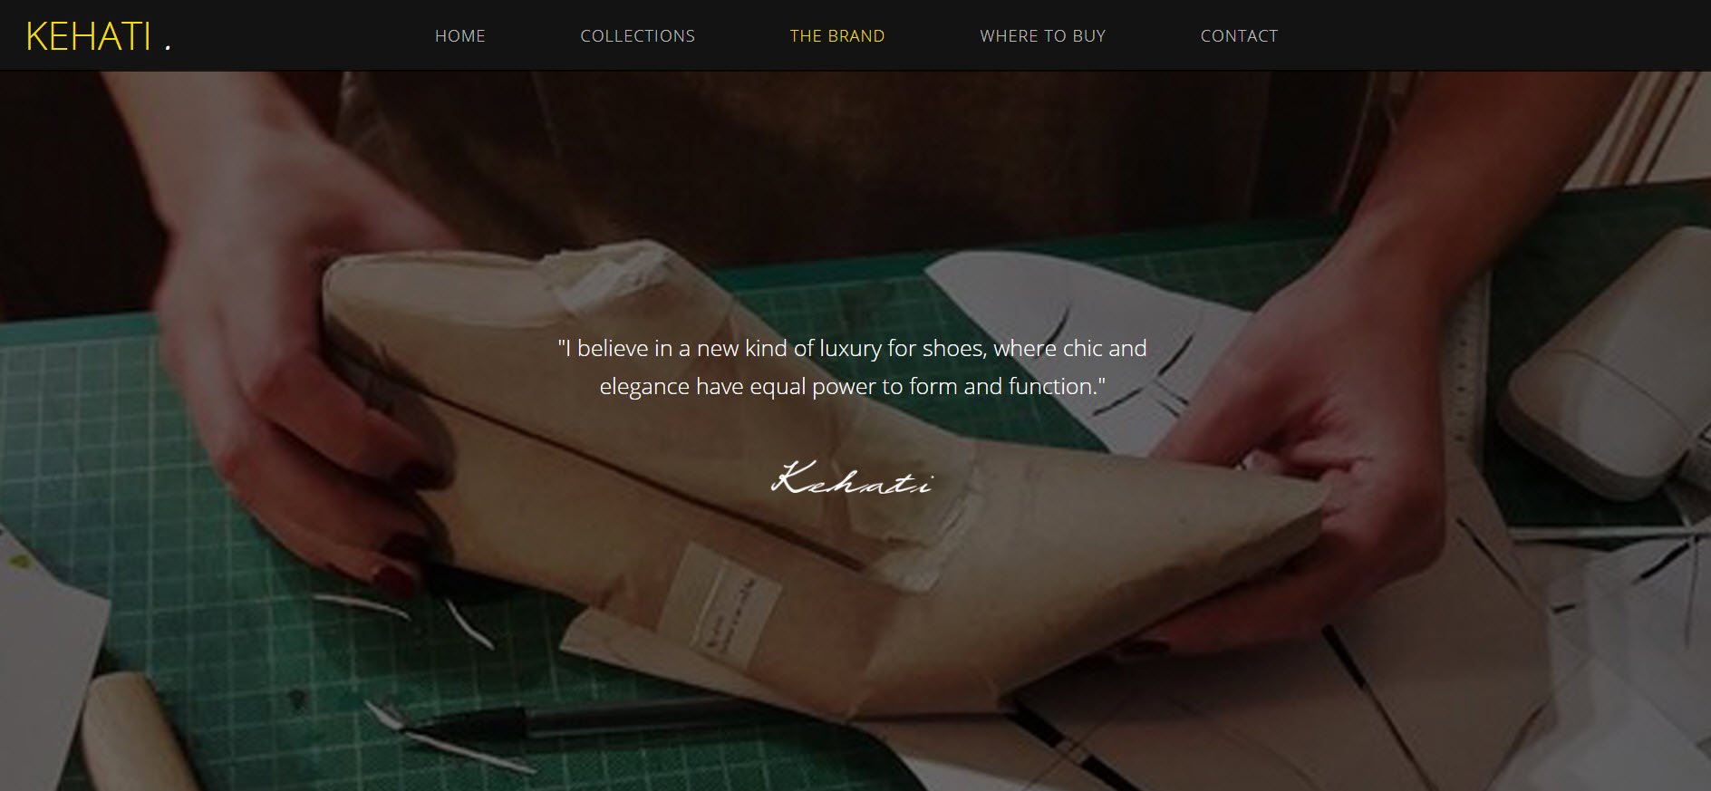

**KONTEN BRAND 1 :**

“We believe that beautiful shoes will bring you beautiful steps that remain stay toward your heart.”

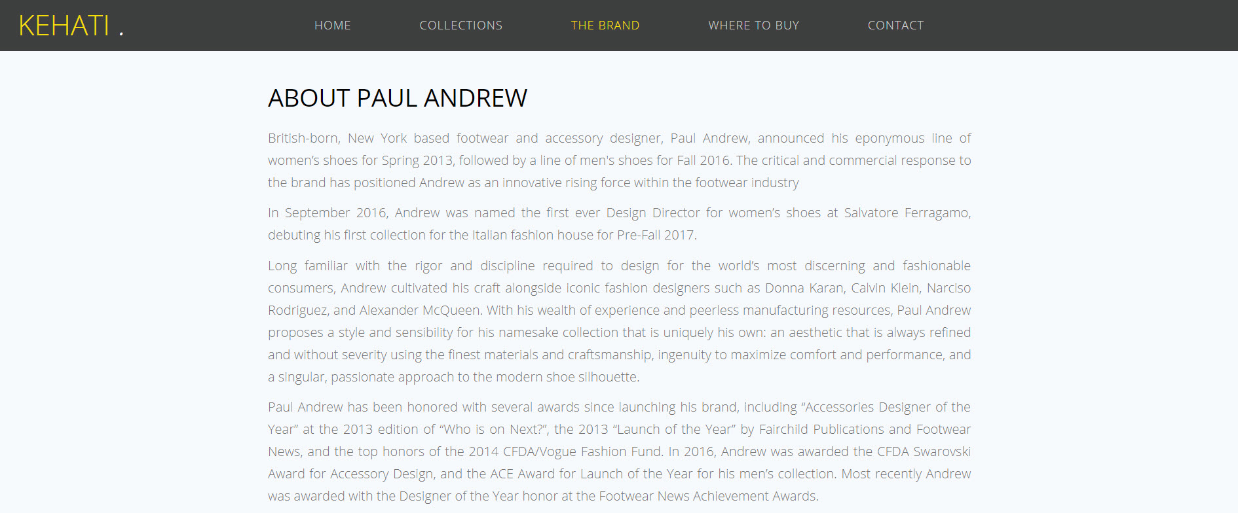

**KONTEN BRAND 2 :**

About Kehati :

Kehati is a women‘s shoes brand that was established in 2018.

Taken from Indonesian language that means toward your heart, Kehati’s signature styles are feminine, minimalism and modern that were packaged in elegant design.

Kehati is an idealism project of our owner that has been in fashion industry for more than 10 years.

We hope that our shoes will fulfil all women’s needs, which are confidence, love and joyful could be started by wearing our beautiful shoes.



**KONTEN BRAND 3 :** hilangkan

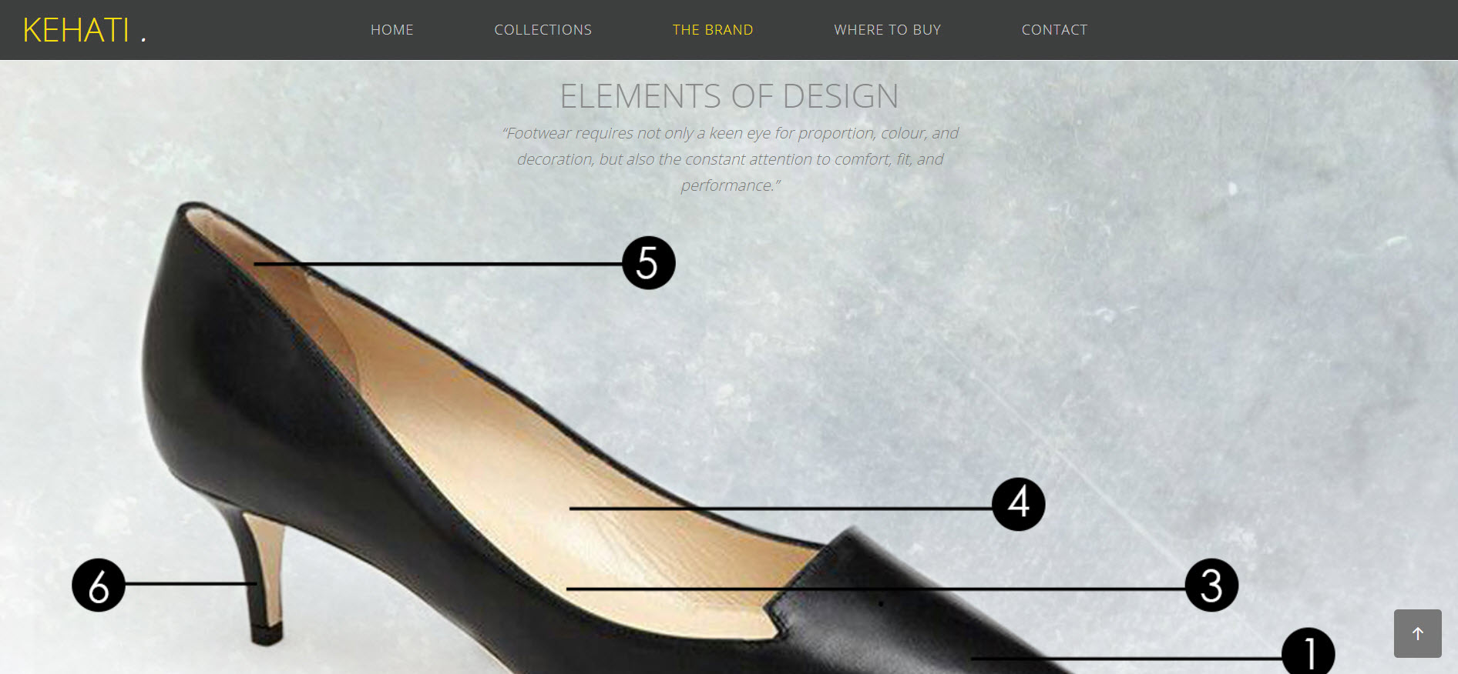

**KONTEN BRAND 4 :**

Element of design : (quotes sama dengan yg ada di capture)

1. Made from qualified materials that beautifully made by hands.
2. Assorted soles which are comfortable and lighting up your steps.
3. Soft pad to support your feet.
4. Smooth Inner lining from synthetic leather.
5. Cover material that protect your feet from irritation.
6. Massive heels that were strengthened with glue and iron to embrace your feet.

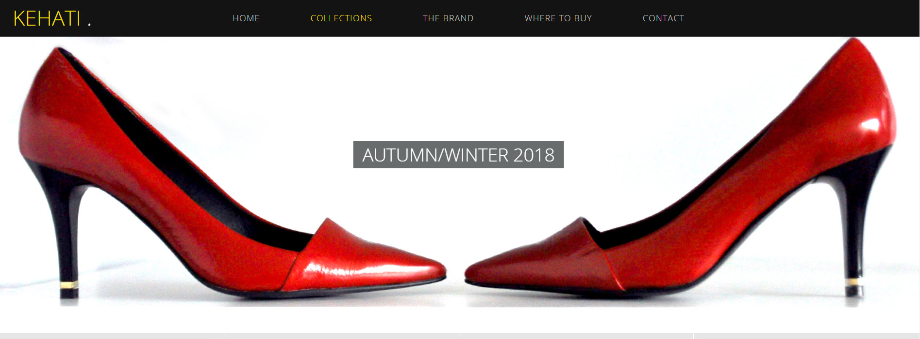

**COLLECTION 1** :

Quotes : Spring / Summer 2019

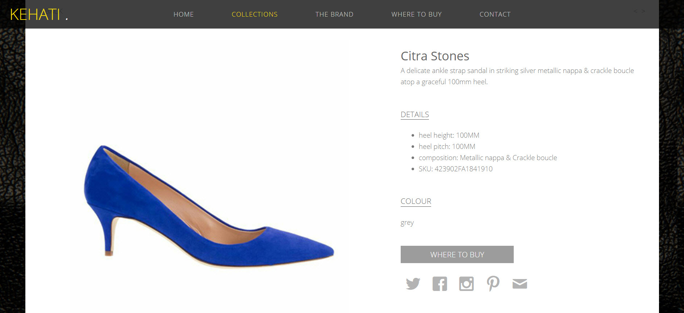

**COLLECTION DETAIL 1** : -menyusul setelah ada foto

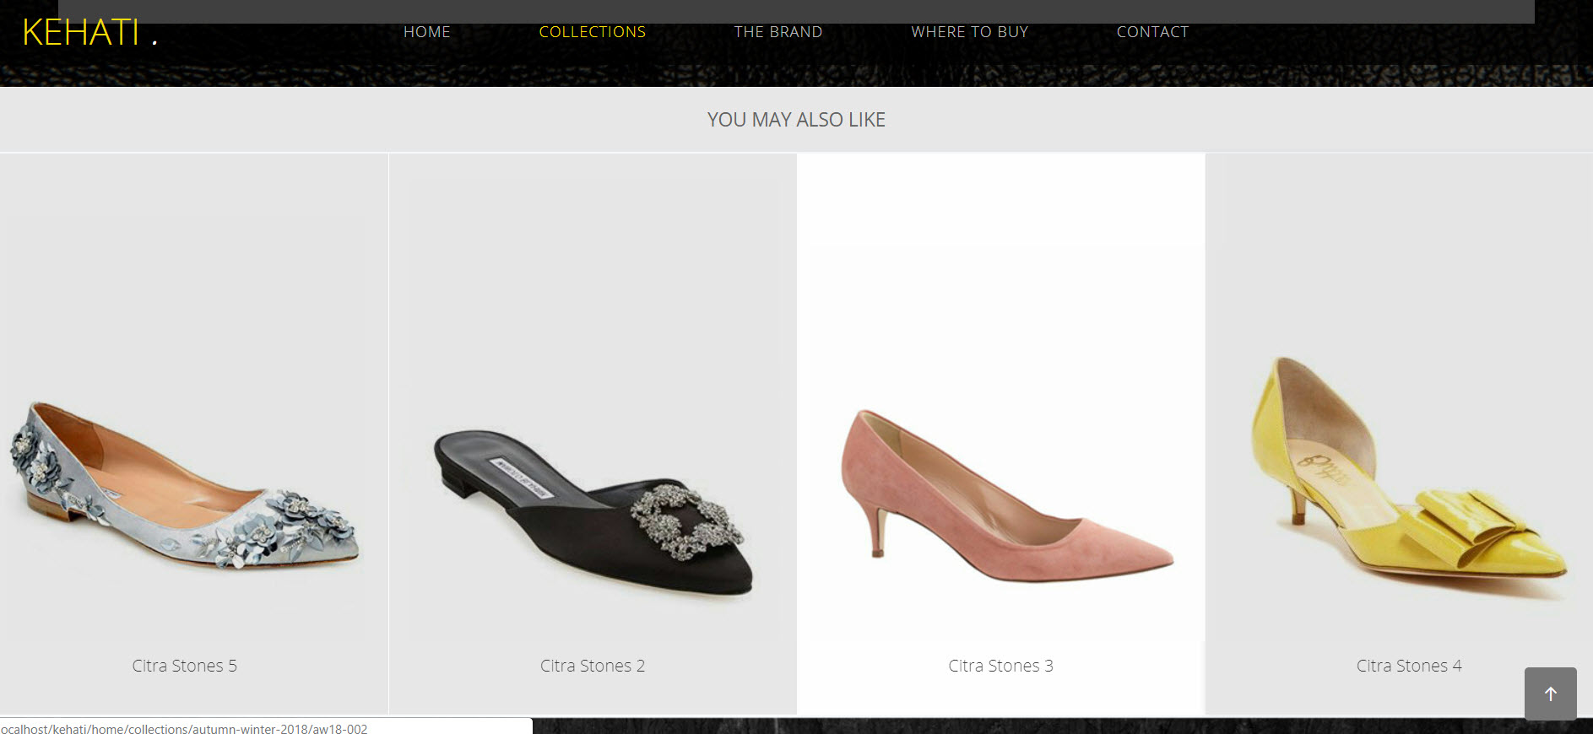

**COLLECTION DETAIL 2** : -menyusul setelah ada foto-

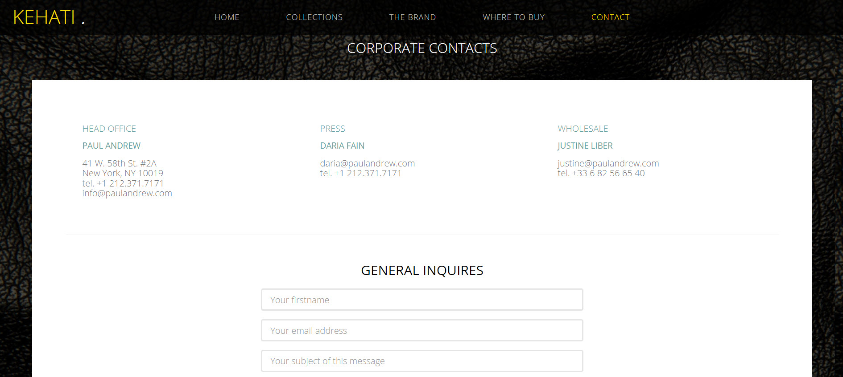

**CONTACT 1** :

Head office : Griya Bandung Asri 1 Blok E nomer 2, 40288 Bojongsoang – Bandung

+62877-4136-3273

[Kehati.shoes@gmail.com](mailto:Kehati.shoes@gmail.com)

Press : Herry ([herryprihamdani@gmail.com](mailto:herryprihamdani@gmail.com))

Customer Service (9 am-5 pm) : whatssap +62877-4136-3273

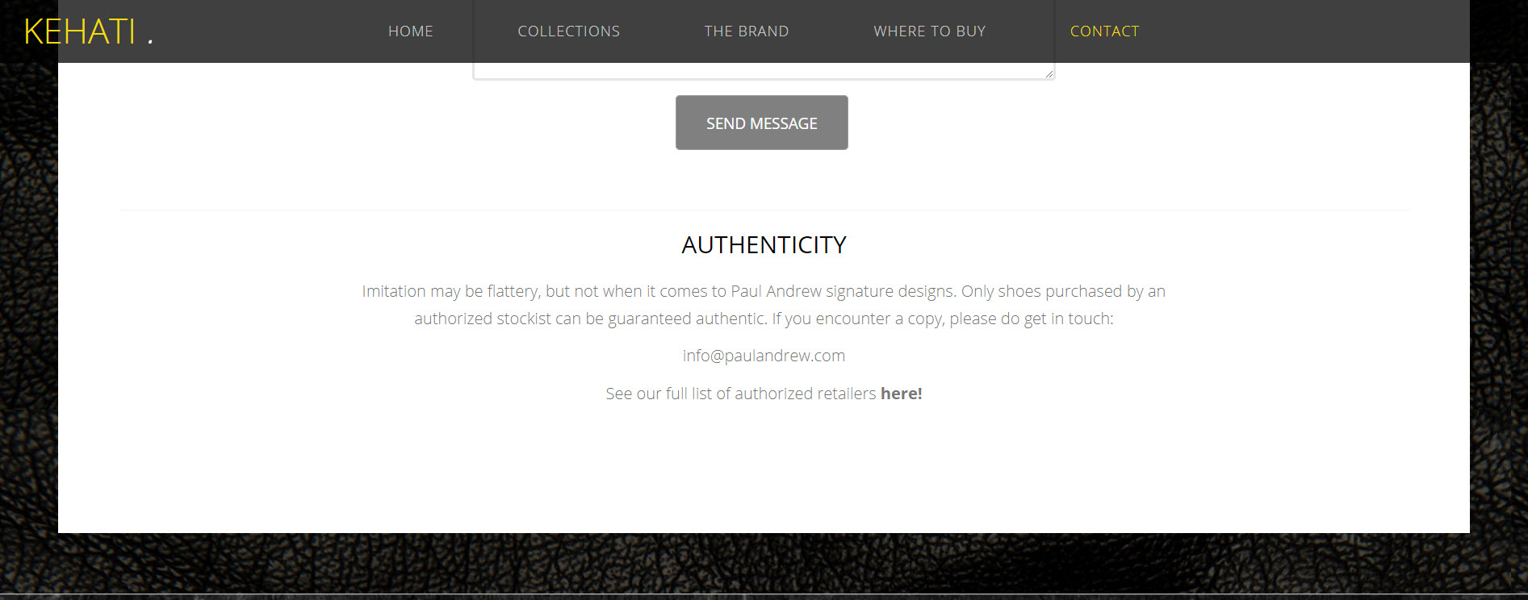

**CONTACT 3 :**

Authenticity : delivering an elegant shoe design that put comfortable as our first priority in many color choices from soft to bright and celebrating feminine as well.

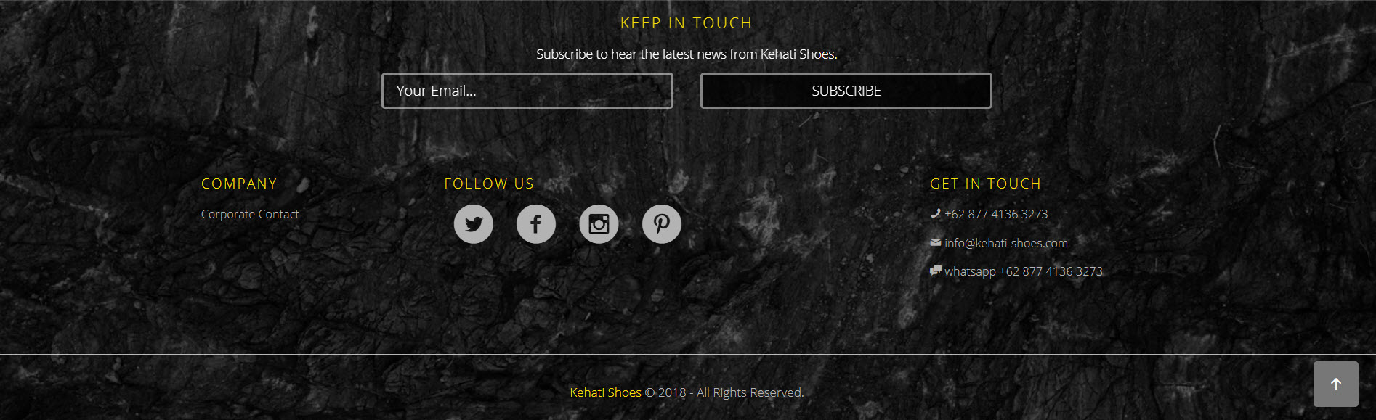

**FOOTER :**

Sama dengan yg ada di capture

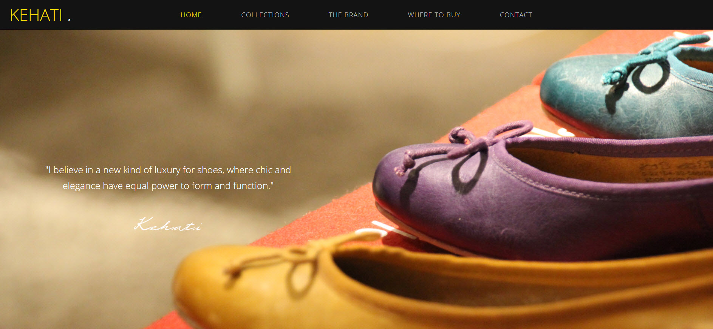

**HOME 1 :**

Quotes sama

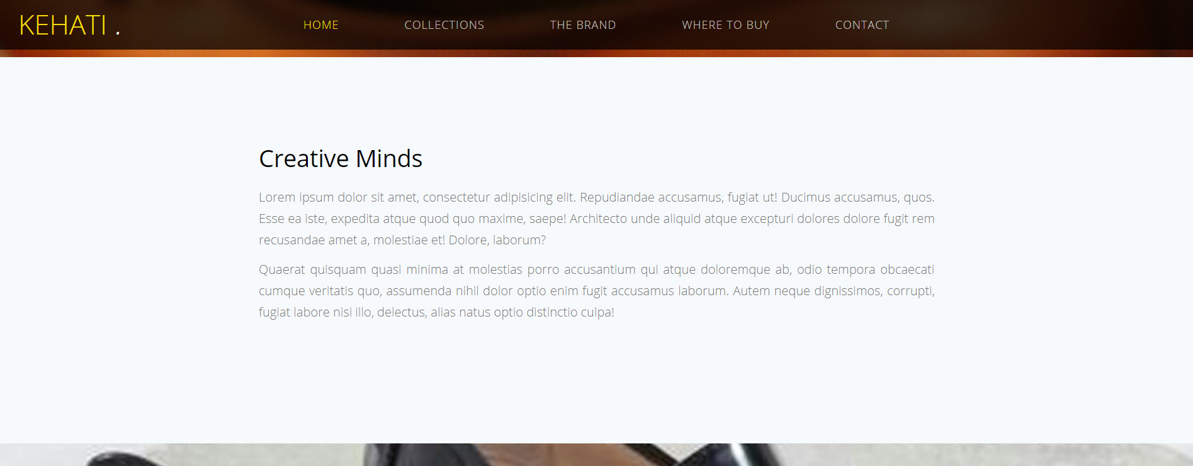

**HOME 2 :**

menyusul

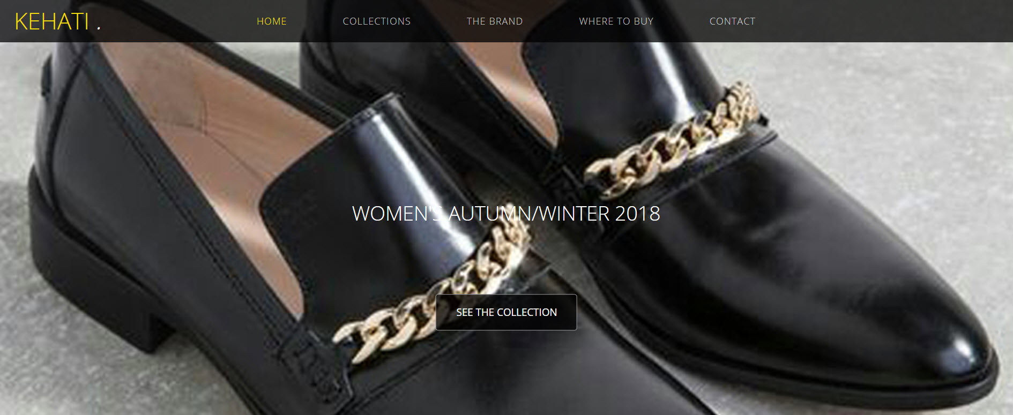

**HOME 3 :**

Spring / Summer 2019

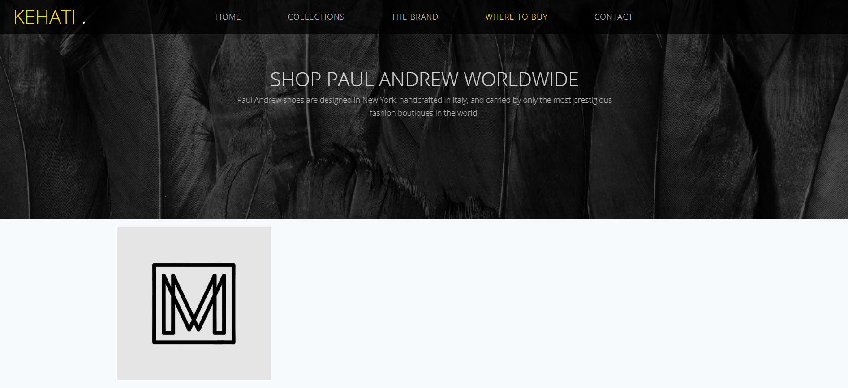

**Where To Buy :**

Kehati shoe’s are designed and handcrafted in Bandung and carried by fashion market place.